Prepared by Khoa

Date: 2013/12/06

**Summary of work today:**

1. Set up a collaborative repository on Github website Set up the project on each individual’s computer - Obstacles & lesson learned
2. Set up a folder for the project following William Stafford Noble’s paper “A Quick Guide to

Organizing Computational Biology Projects” and push it to the repository - Obstacles & lesson learned

1. Added data to the project (at MAP/data/testdata.tar.gz), README files for each folder and write the first result (this document **:^)** )

**Details are below:**

1. Set up a collaborative project on Github website

* Each of us (Khoa, Namrata and Shalini) signed up for an account on Github website
* Namrata created a repository on Github website for the project ‘Reducing noise in protein multialignments’ (see MAP/doc/project_descriptionappbio13.htm for the project’s description). After finishing , a link for cloning the project is available at https://github.com/namrata007/MAP.git
* Namrata (the owner of the repository) added Khoa and Shalini as collaborators on Github website

Set up the project on each individual’s computer (**bold texts** are commands run on Ubuntu)

* Each of us downloaded git application to be able to use the git commands
* We configure username and email on our own computer:

**git config --global user.name "collaborator_name"** …....this is the username of one person on Github website

**git config --global user.email "collaborator_email"** ……this is the email that one used while registering for a Github account

* Everyone made a clone of the repository in one’s own computer

**git clone https://github.com/namrata007/MAP.git**

A folder named MAP is created in our own machine

* Following are the commands on first run to test the git commands

**cd MAP** .....enter into MAP folder

**touch namrata.txt** .......try creating a file

**git add namrata.txt** …….tell git to track the file (staging the file in other words)

**git commit -m 'My file-namrata'** …......commit the change just made

**git push origin master** ….......push to repository

**Username for 'https://github.com':** ….....enter credentials

**Password for 'https://namrata007@github.com':**

Obstacles & Lesson learned:

Obstacles: ‘git push origin master’ did not work and give the error 403.

Reason: we skipped the step to add the others as collaborators for the repository on Github website

Solution: the owner of the repository had to add the others as collaborators on the Github website

1. Set up a folder for the project following William Stafford Noble’s paper

We set up a folder structure for our project today following the suggested folder structure from the paper “A Quick Guide to Organizing Computational Biology Projects” by William Stafford Noble (a soft copy of the paper can be found at MAP/doc/journal.pcbi.1000424.pdf)

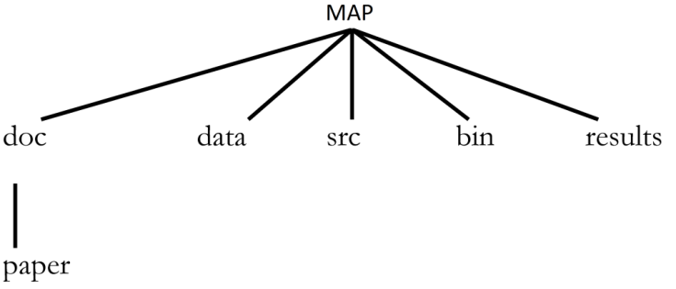

Obstacles & Lesson learned:

Obstacle: At first, we used the command **‘git add .’** to track (stage) all the folders and files just created in MAP folder. However, no folders show up after we pushed the changes to the repository.

Reason: empty folders cannot be pushed to Github repository.

Solution: we created temporary file in each folder, then pushed the changes to the repository